For Annexure

Verimax rotattion

|  |  |  |  |  |  |  |  |  |  |  |  |  |  |
| --- | --- | --- | --- | --- | --- | --- | --- | --- | --- | --- | --- | --- | --- |
| **Correlation Matrix** | | | | | | | | | | | | | |
|  | | DIS 2 28G | DIS 3 29G | DIS 4 30G | DIS 5 31G | DIS 6 32G | DIS 7 33G | DIS 8 34G | DIS 9 35G | DIS 10 36G | DIS 11 37G | DIS 12 38G | DIS 13 39G |
|  | |  |  |  |  |  |  |  |  |  |  |  |  |
| Correlation | DIS 2 28G | 1.000 | .574 | .468 | .013 | -.051 | -.065 | -.155 | -.212 | -.350 | -.212 | -.314 | -.296 |
| DIS 3 29G | .574 | 1.000 | .677 | .029 | -.094 | -.116 | -.265 | -.173 | -.255 | -.358 | -.414 | -.428 |
| DIS 4 30G | .468 | .677 | 1.000 | .087 | -.049 | -.058 | -.340 | -.266 | -.236 | -.552 | -.555 | -.511 |
| DIS 5 31G | .013 | .029 | .087 | 1.000 | .327 | .360 | .276 | .241 | .184 | .158 | .070 | .134 |
| DIS 6 32G | -.051 | -.094 | -.049 | .327 | 1.000 | .665 | .420 | .488 | .441 | .322 | .392 | .386 |
| DIS 7 33G | -.065 | -.116 | -.058 | .360 | .665 | 1.000 | .468 | .429 | .324 | .323 | .369 | .414 |
| DIS 8 34G | -.155 | -.265 | -.340 | .276 | .420 | .468 | 1.000 | .580 | .444 | .569 | .558 | .650 |
| DIS 9 35G | -.212 | -.173 | -.266 | .241 | .488 | .429 | .580 | 1.000 | .652 | .441 | .534 | .575 |
| DIS 10 36G | -.350 | -.255 | -.236 | .184 | .441 | .324 | .444 | .652 | 1.000 | .366 | .462 | .486 |
| DIS 11 37G | -.212 | -.358 | -.552 | .158 | .322 | .323 | .569 | .441 | .366 | 1.000 | .834 | .741 |
| DIS 12 38G | -.314 | -.414 | -.555 | .070 | .392 | .369 | .558 | .534 | .462 | .834 | 1.000 | .789 |
| DIS 13 39G | -.296 | -.428 | -.511 | .134 | .386 | .414 | .650 | .575 | .486 | .741 | .789 | 1.000 |
| Sig. (1-tailed) | DIS 2 28G |  | .000 | .000 | .439 | .268 | .216 | .029 | .005 | .000 | .005 | .000 | .000 |
| DIS 3 29G | .000 |  | .000 | .364 | .125 | .079 | .001 | .017 | .001 | .000 | .000 | .000 |
| DIS 4 30G | .000 | .000 |  | .145 | .274 | .241 | .000 | .001 | .002 | .000 | .000 | .000 |
| DIS 5 31G | .439 | .364 | .145 |  | .000 | .000 | .000 | .002 | .012 | .027 | .197 | .051 |
| DIS 6 32G | .268 | .125 | .274 | .000 |  | .000 | .000 | .000 | .000 | .000 | .000 | .000 |
| DIS 7 33G | .216 | .079 | .241 | .000 | .000 |  | .000 | .000 | .000 | .000 | .000 | .000 |
| DIS 8 34G | .029 | .001 | .000 | .000 | .000 | .000 |  | .000 | .000 | .000 | .000 | .000 |
| DIS 9 35G | .005 | .017 | .001 | .002 | .000 | .000 | .000 |  | .000 | .000 | .000 | .000 |
| DIS 10 36G | .000 | .001 | .002 | .012 | .000 | .000 | .000 | .000 |  | .000 | .000 | .000 |
| DIS 11 37G | .005 | .000 | .000 | .027 | .000 | .000 | .000 | .000 | .000 |  | .000 | .000 |
| DIS 12 38G | .000 | .000 | .000 | .197 | .000 | .000 | .000 | .000 | .000 | .000 |  | .000 |
| DIS 13 39G | .000 | .000 | .000 | .051 | .000 | .000 | .000 | .000 | .000 | .000 | .000 |  |

|  |  |  |
| --- | --- | --- |
| **KMO and Bartlett's Test** | | |
| Kaiser-Meyer-Olkin Measure of Sampling Adequacy. | | .847 |
| Bartlett's Test of Sphericity | Approx. Chi-Square | 1002.158 |
| df | 66 |
| Sig. | .000 |

|  |  |  |  |  |  |  |  |  |  |
| --- | --- | --- | --- | --- | --- | --- | --- | --- | --- |
| **Total Variance Explained** | | | | | | | | | |
| Component | Initial Eigenvalues | | | Extraction Sums of Squared Loadings | | | Rotation Sums of Squared Loadings | | |
| Total | % of Variance | Cumulative % | Total | % of Variance | Cumulative % | Total | % of Variance | Cumulative % |
| 1 | 5.247 | 43.725 | 43.725 | 5.247 | 43.725 | 43.725 | 3.403 | 28.360 | 28.360 |
| 2 | 2.036 | 16.966 | 60.690 | 2.036 | 16.966 | 60.690 | 2.770 | 23.084 | 51.445 |
| 3 | 1.035 | 8.628 | 69.319 | 1.035 | 8.628 | 69.319 | 2.145 | 17.874 | 69.319 |
| 4 | .844 | 7.037 | 76.355 |  |  |  |  |  |  |
| 5 | .707 | 5.894 | 82.250 |  |  |  |  |  |  |
| 6 | .482 | 4.015 | 86.265 |  |  |  |  |  |  |
| 7 | .414 | 3.446 | 89.711 |  |  |  |  |  |  |
| 8 | .328 | 2.734 | 92.445 |  |  |  |  |  |  |
| 9 | .299 | 2.490 | 94.935 |  |  |  |  |  |  |
| 10 | .268 | 2.236 | 97.171 |  |  |  |  |  |  |
| 11 | .204 | 1.698 | 98.869 |  |  |  |  |  |  |
| 12 | .136 | 1.131 | 100.000 |  |  |  |  |  |  |
| Extraction Method: Principal Component Analysis. | | | | | | | | | |

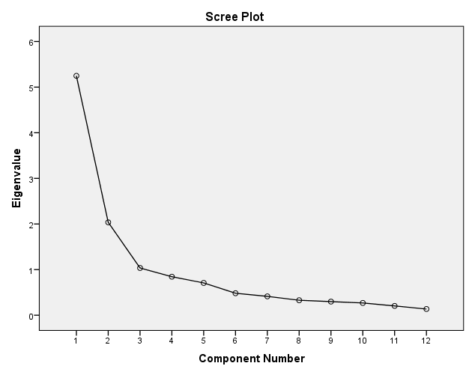

**OBLIMIN rotation**

|  |  |  |  |  |  |  |  |  |  |  |  |  |  |
| --- | --- | --- | --- | --- | --- | --- | --- | --- | --- | --- | --- | --- | --- |
| **Correlation Matrix** | | | | | | | | | | | | | |
|  | | DIS 2 28G | DIS 3 29G | DIS 4 30G | DIS 5 31G | DIS 6 32G | DIS 7 33G | DIS 8 34G | DIS 9 35G | DIS 10 36G | DIS 11 37G | DIS 12 38G | DIS 13 39G |
| Correlation | DIS 2 28G | 1.000 | .551 | .432 | -.105 | -.021 | -.007 | -.066 | -.157 | -.328 | -.115 | -.238 | -.226 |
| DIS 3 29G | .551 | 1.000 | .623 | -.172 | -.017 | -.062 | -.171 | -.048 | -.173 | -.216 | -.272 | -.308 |
| DIS 4 30G | .432 | .623 | 1.000 | -.122 | .027 | .044 | -.264 | -.167 | -.126 | -.416 | -.432 | -.410 |
| DIS 5 31G | -.105 | -.172 | -.122 | 1.000 | .499 | .520 | .528 | .442 | .361 | .492 | .376 | .394 |
| DIS 6 32G | -.021 | -.017 | .027 | .499 | 1.000 | .747 | .448 | .480 | .423 | .329 | .384 | .395 |
| DIS 7 33G | -.007 | -.062 | .044 | .520 | .747 | 1.000 | .475 | .445 | .326 | .289 | .368 | .401 |
| DIS 8 34G | -.066 | -.171 | -.264 | .528 | .448 | .475 | 1.000 | .611 | .440 | .543 | .520 | .679 |
| DIS 9 35G | -.157 | -.048 | -.167 | .442 | .480 | .445 | .611 | 1.000 | .663 | .430 | .495 | .562 |
| DIS 10 36G | -.328 | -.173 | -.126 | .361 | .423 | .326 | .440 | .663 | 1.000 | .311 | .424 | .475 |
| DIS 11 37G | -.115 | -.216 | -.416 | .492 | .329 | .289 | .543 | .430 | .311 | 1.000 | .833 | .711 |
| DIS 12 38G | -.238 | -.272 | -.432 | .376 | .384 | .368 | .520 | .495 | .424 | .833 | 1.000 | .785 |
| DIS 13 39G | -.226 | -.308 | -.410 | .394 | .395 | .401 | .679 | .562 | .475 | .711 | .785 | 1.000 |
| Sig. (1-tailed) | DIS 2 28G |  | .000 | .000 | .122 | .409 | .468 | .231 | .041 | .000 | .101 | .004 | .006 |
| DIS 3 29G | .000 |  | .000 | .027 | .426 | .247 | .029 | .299 | .027 | .008 | .001 | .000 |
| DIS 4 30G | .000 | .000 |  | .088 | .384 | .312 | .001 | .031 | .081 | .000 | .000 | .000 |
| DIS 5 31G | .122 | .027 | .088 |  | .000 | .000 | .000 | .000 | .000 | .000 | .000 | .000 |
| DIS 6 32G | .409 | .426 | .384 | .000 |  | .000 | .000 | .000 | .000 | .000 | .000 | .000 |
| DIS 7 33G | .468 | .247 | .312 | .000 | .000 |  | .000 | .000 | .000 | .001 | .000 | .000 |
| DIS 8 34G | .231 | .029 | .001 | .000 | .000 | .000 |  | .000 | .000 | .000 | .000 | .000 |
| DIS 9 35G | .041 | .299 | .031 | .000 | .000 | .000 | .000 |  | .000 | .000 | .000 | .000 |
| DIS 10 36G | .000 | .027 | .081 | .000 | .000 | .000 | .000 | .000 |  | .000 | .000 | .000 |
| DIS 11 37G | .101 | .008 | .000 | .000 | .000 | .001 | .000 | .000 | .000 |  | .000 | .000 |
| DIS 12 38G | .004 | .001 | .000 | .000 | .000 | .000 | .000 | .000 | .000 | .000 |  | .000 |
| DIS 13 39G | .006 | .000 | .000 | .000 | .000 | .000 | .000 | .000 | .000 | .000 | .000 |  |

|  |  |  |  |
| --- | --- | --- | --- |
| **Component Correlation Matrix** | | | |
| Component | 1 | 2 | 3 |
| 1 | 1.000 | -.055 | .402 |
| 2 | -.055 | 1.000 | -.279 |
| 3 | .402 | -.279 | 1.000 |
| Extraction Method: Principal Component Analysis.  Rotation Method: Oblimin with Kaiser Normalization. | | | |

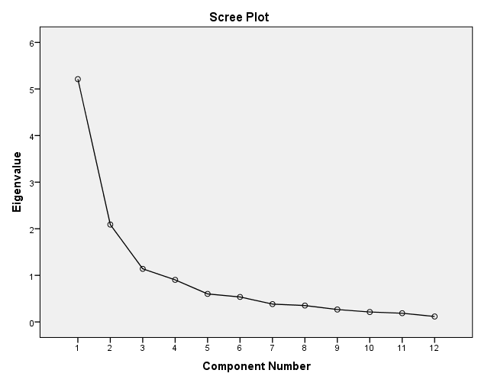

|  |  |  |  |
| --- | --- | --- | --- |
| **Structure Matrix** | | | |
|  | Component | | |
| 1 | 2 | 3 |
| DIS 6 32G | .838 |  | .302 |
| DIS 7 33G | .816 |  | .295 |
| DIS 9 35G | .754 | -.158 | .510 |
| DIS 10 36G | .698 | -.358 | .341 |
| DIS 5 31G | .682 | -.102 | .454 |
| DIS 2 28G | -.134 | .863 | -.141 |
| DIS 3 29G |  | .844 | -.325 |
| DIS 4 30G |  | .713 | -.581 |
| DIS 11 37G | .390 | -.167 | .916 |
| DIS 12 38G | .458 | -.282 | .895 |
| DIS 13 39G | .536 | -.301 | .865 |
| DIS 8 34G | .655 | -.117 | .687 |
| Extraction Method: Principal Component Analysis.  Rotation Method: Oblimin with Kaiser Normalization. | | | |